**Container :**

A way to package application with all the necessary dependencies and configuration

Portable artifact, easily shared and moved around

Everything isolated in 1 place, makes development and deployment easier

Container lives in container repository

Can run multiple versions of a software(container) on a single physical machine

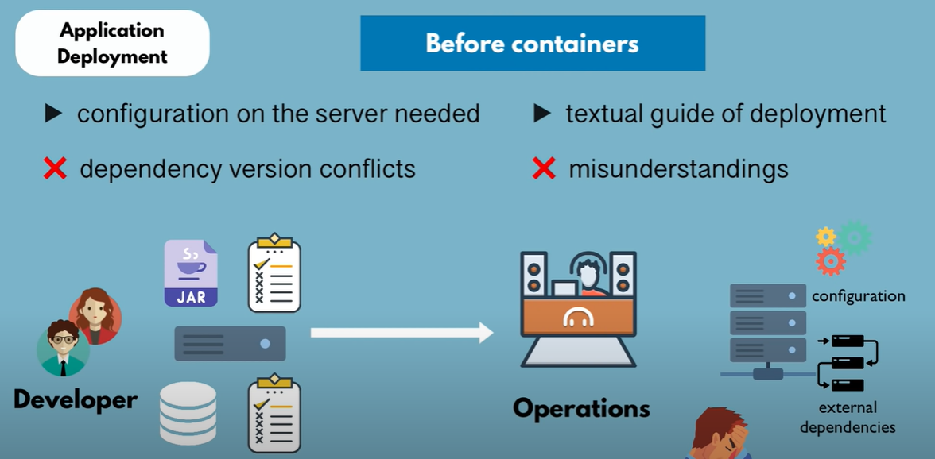

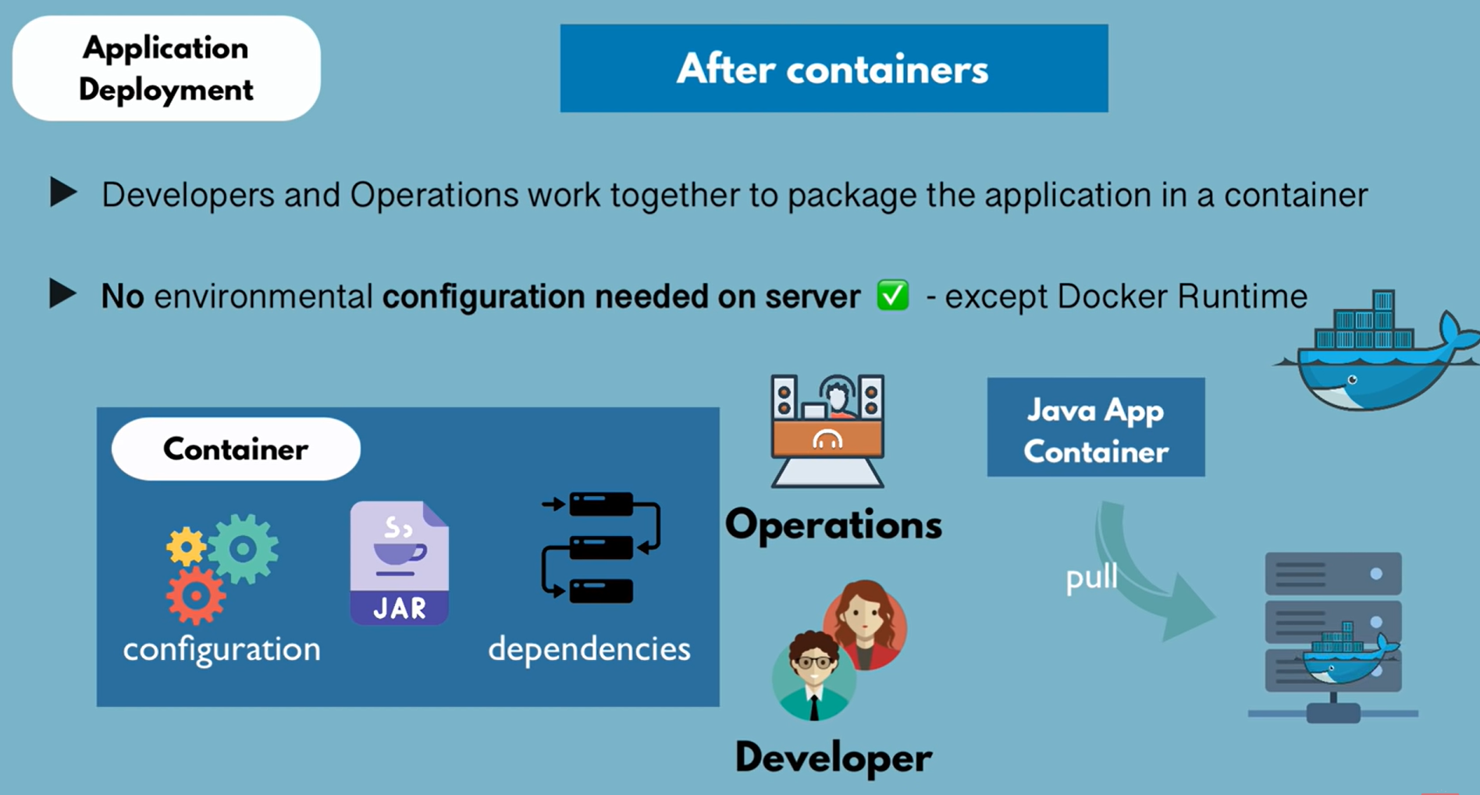

Technically –

Layers of images

Mostly Linux Base Image, because small in size

Application image on top

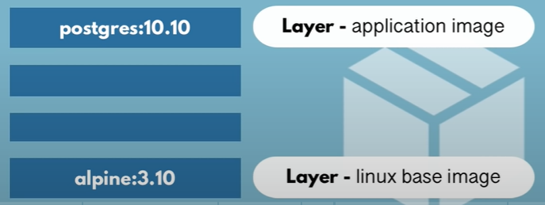

docker run postgres : 9.6

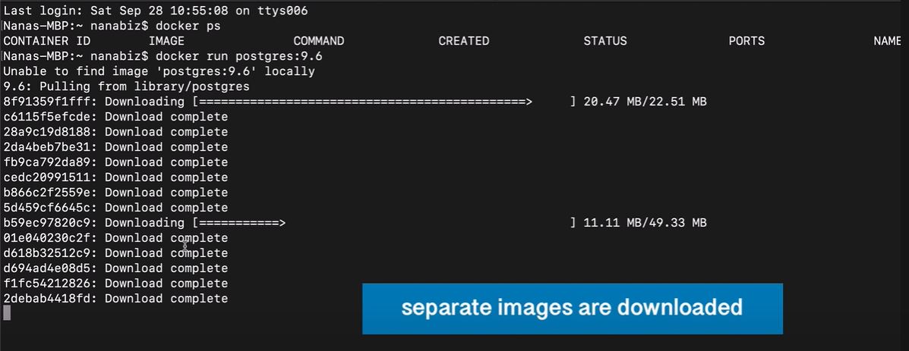

If image not present locally, it will pull it from docker hub and then run it inside of a container

Images are downloaded from docker hub

Images are downloaded as layers.

Advantage of layers : when we pull another container (docker run postgres : 10.2), the layers will be not be downloaded again, and will be reused from 9.6

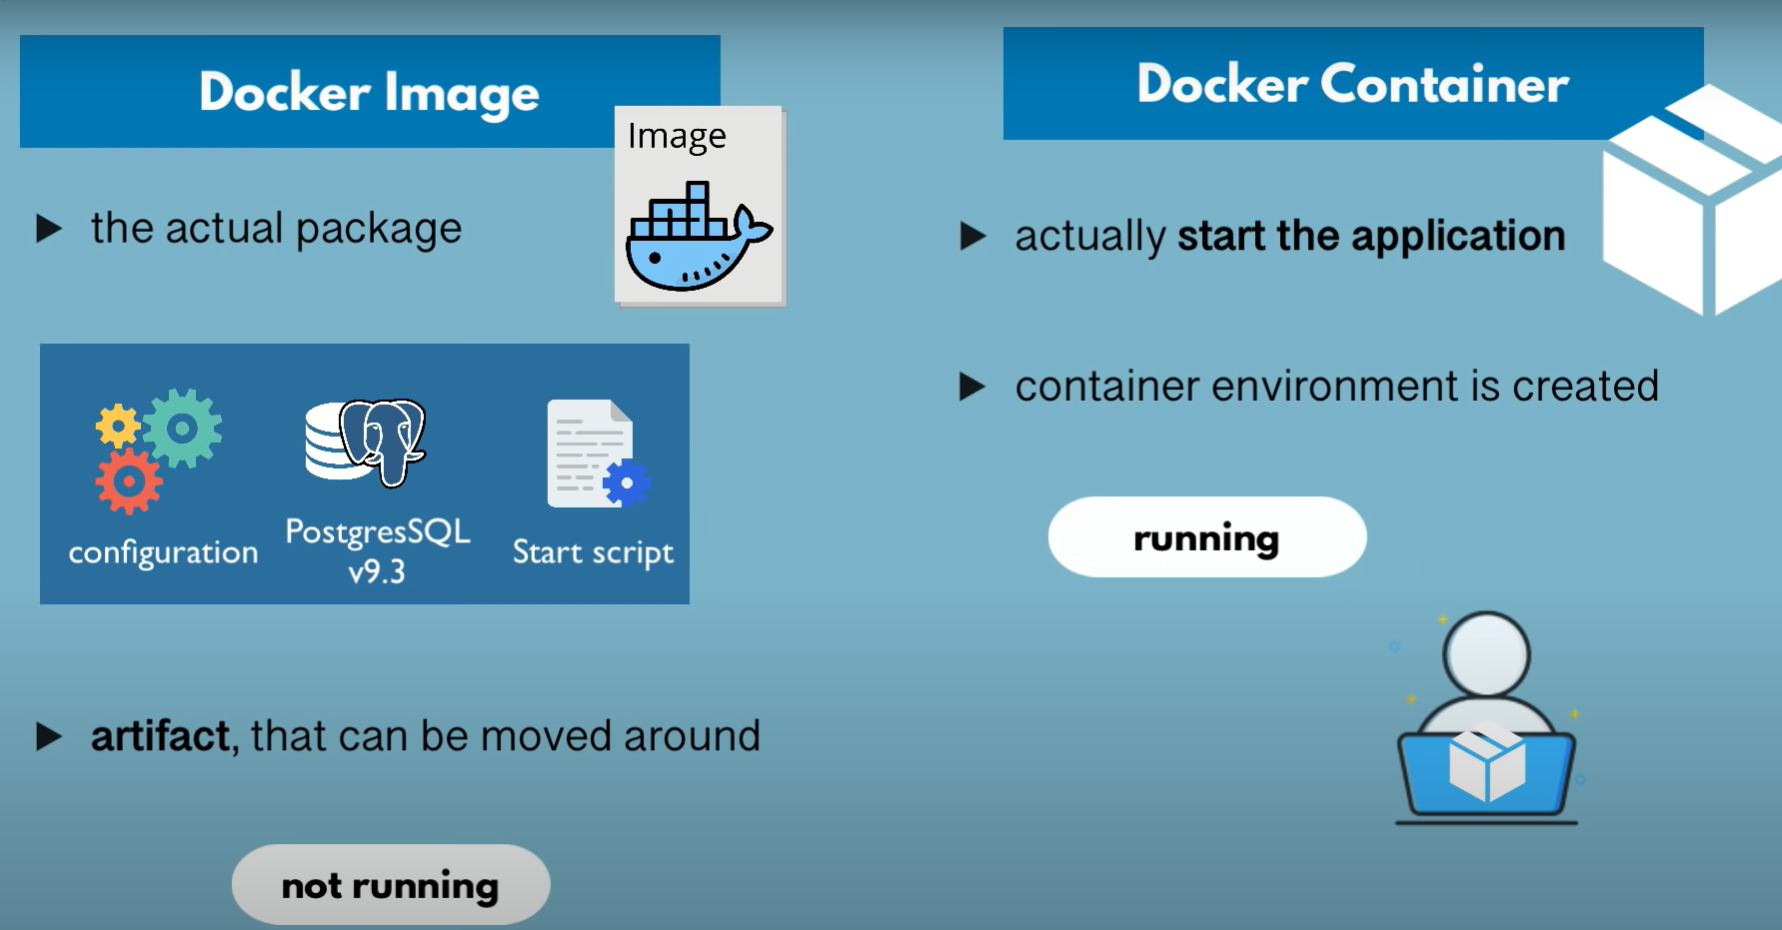

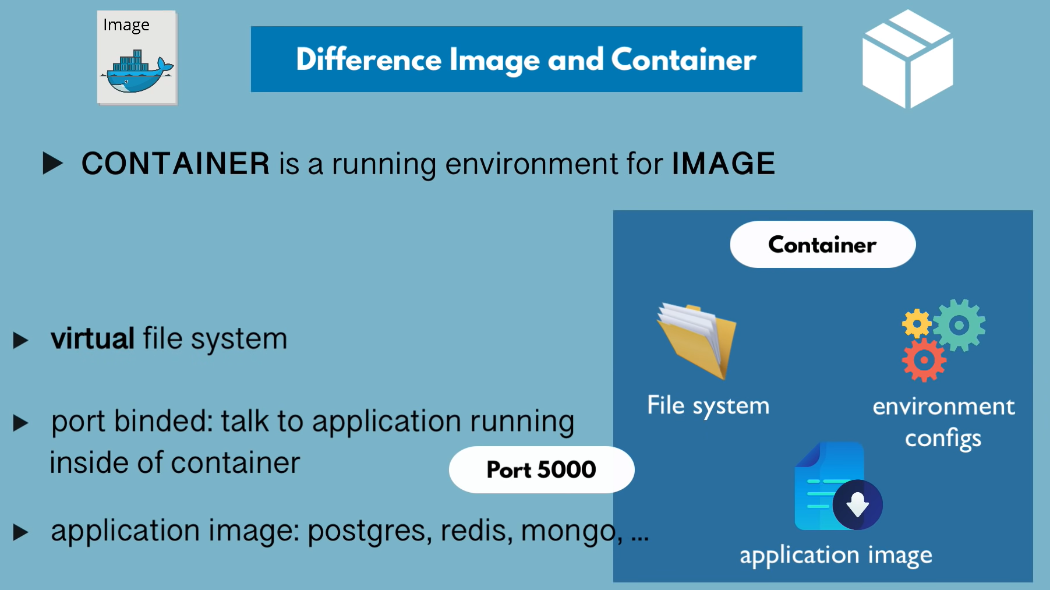

Running 2 different versions of postgres on a single machine

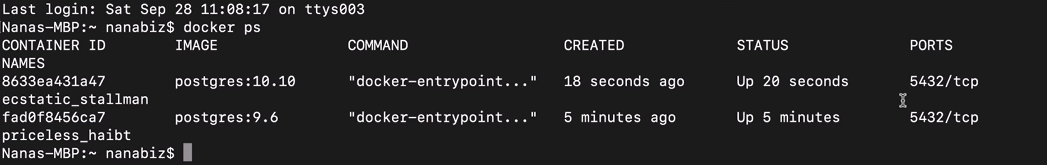

How OS works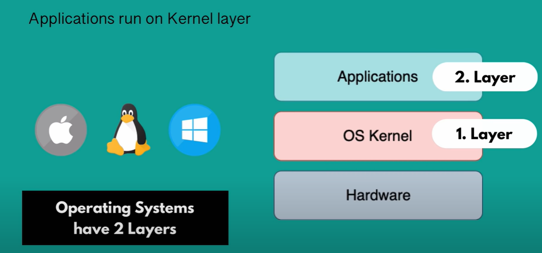

Difference between Docker and VM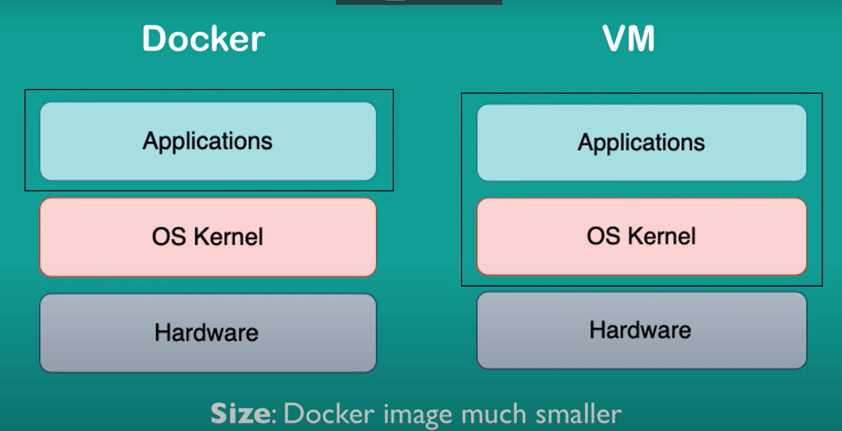

Docker virtualizes Applications layer

* therefore size is smaller
* faster to start up and run apps
* cannot run on different OS

VM brings its own kernal along with it

* VM of any OS can run on any OS host

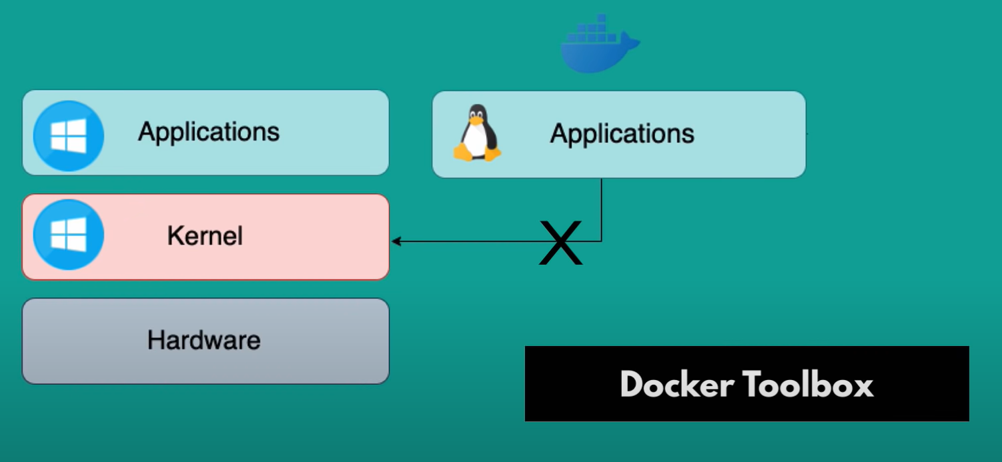

But Docker toolbox can help in running different OS containers on different OS hosts

docker images



docker rmi <image name/containerId>

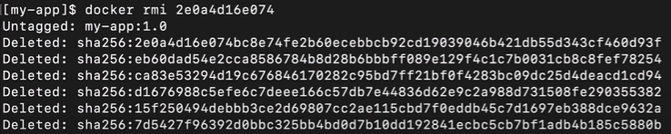

can delete an image only after the containers using it is also removed

docker tag <old image name> <new image name>



Renaming the image

Creates a copy of old image and saves it using new image name

docker run <name/containerId>

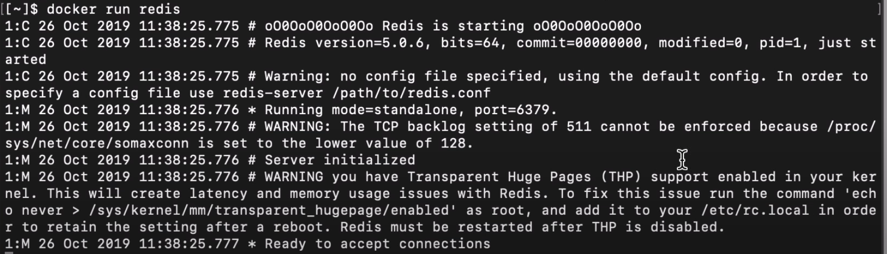

Creates a new container and starts it

Press Ctrl + c to exit and stop container

docker run -d <name/containerId>



Runs container in detached mode

Can use terminal for other uses

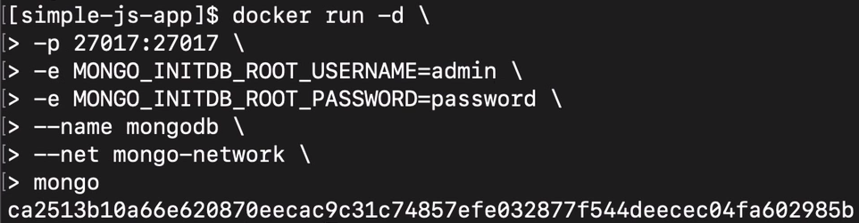

\ – to go to next line

-p – to configure port

-e – set environment variables for the container

--net – to define network for the container

docker rm <name/containerId>

removes the container

docker start <name/containerId>



Start the container

docker stop <name/containerId>



Stop the container

docker ps -a



List all stopped and running containers

docker run -p<host port> : <container port> <name>

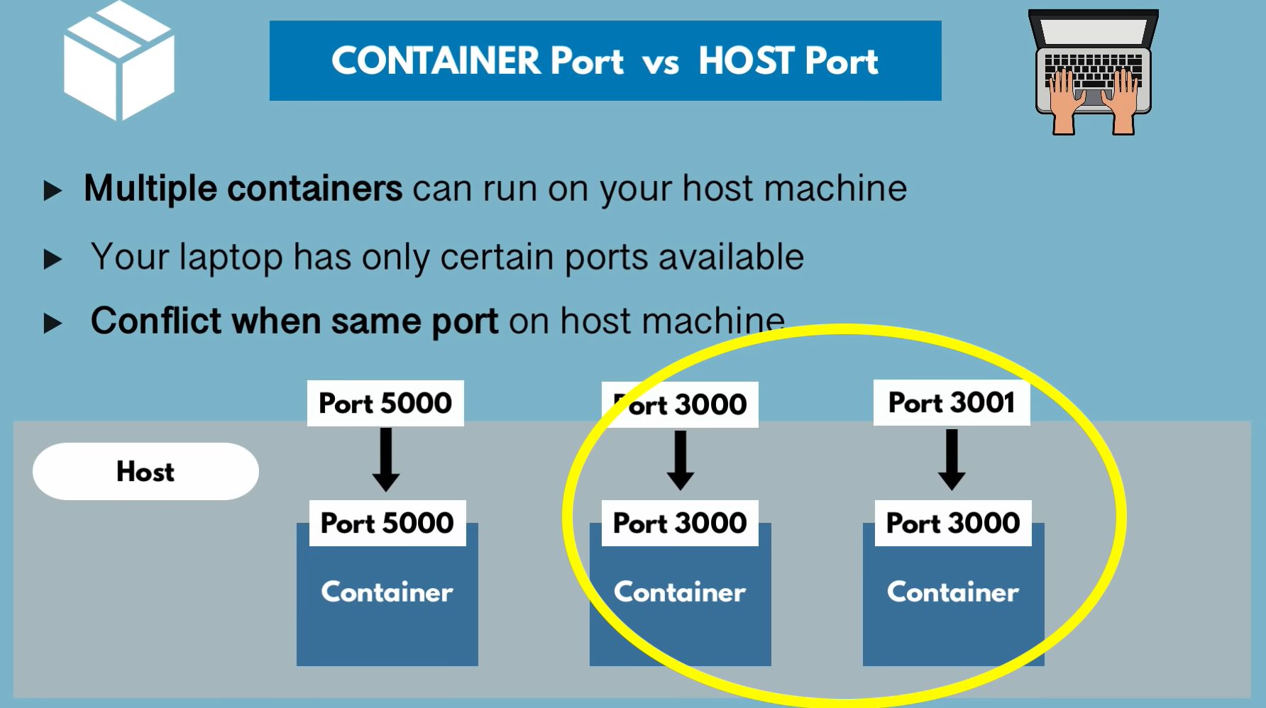



We have mapped port 6000 to redis container and 6001 to redis:4.0 container







docker logs <name/containerId>

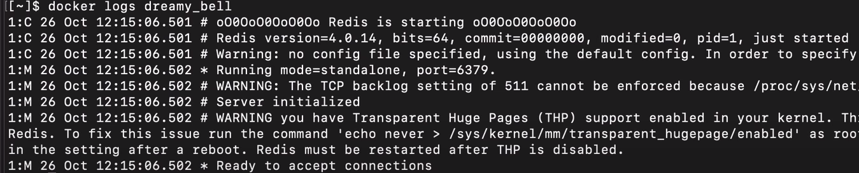

docker logs -f <name/containerId>

To streamline logs from a container

docker run --name <new-name> <present-name>



docker exec -it <name/containerId> /bin/bash

if /bin/bash doesn’t work, try /bin/sh

* Get the terminal of a running container

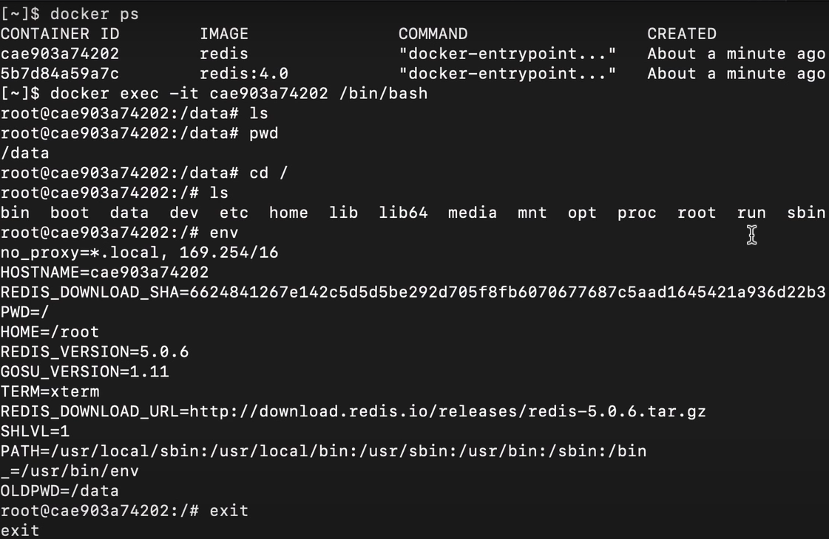

* Type exit to exit the container’s terminal

Docker workflow

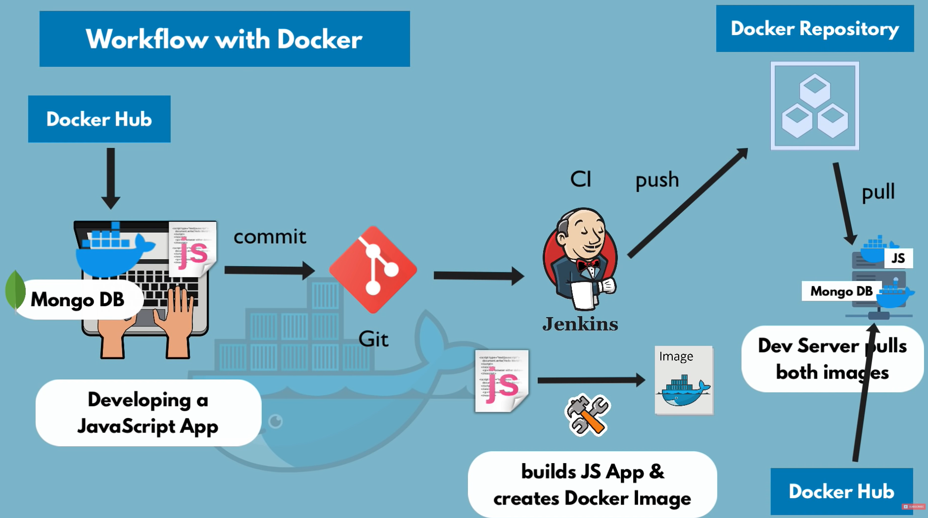

Commit triggers a jenkins build, build will be pushed to private docker repo

Server pulls our app image from the private docker repo and a MongoDB image from docker hub and starts up

Docker network

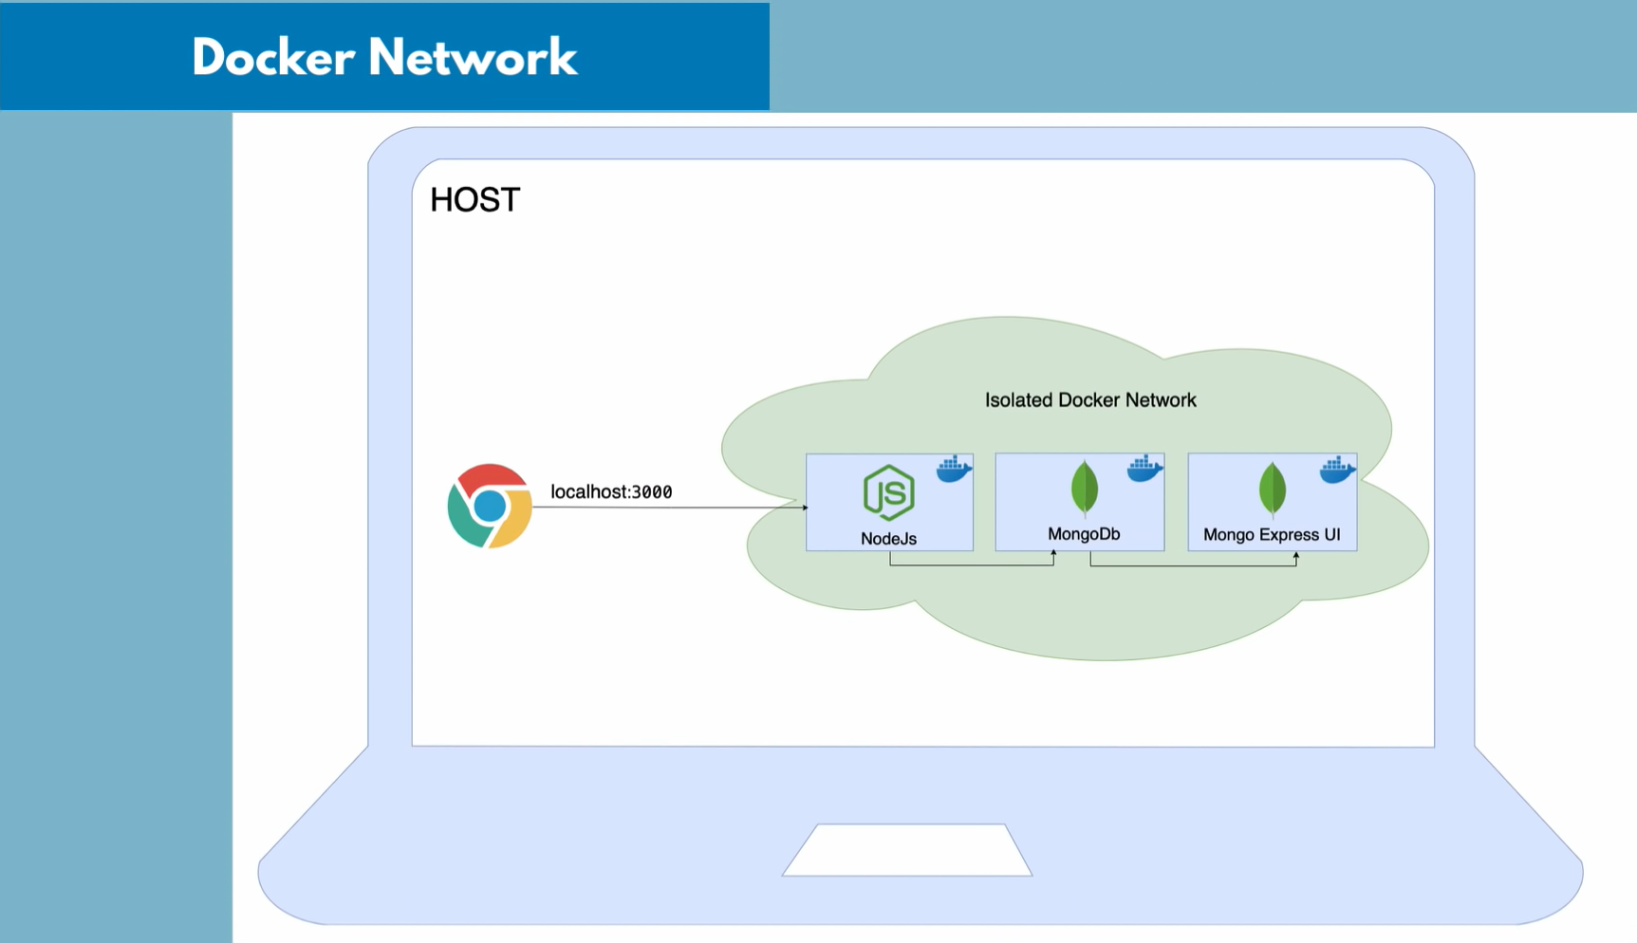Containers created inside a network can communicate with each other

docker network create <network name>



docker network ls

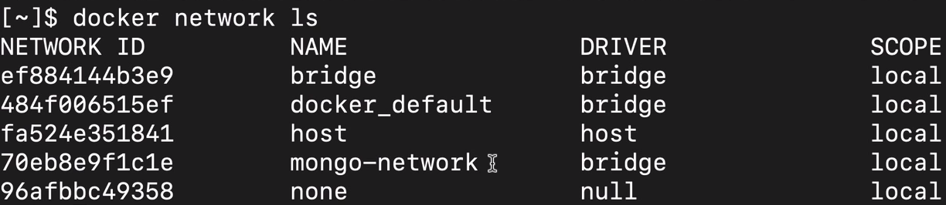

Let’s develop a nodejs app that uses MongoDB using container

In terminal create a network and under it, start mongo and mongo-express containers

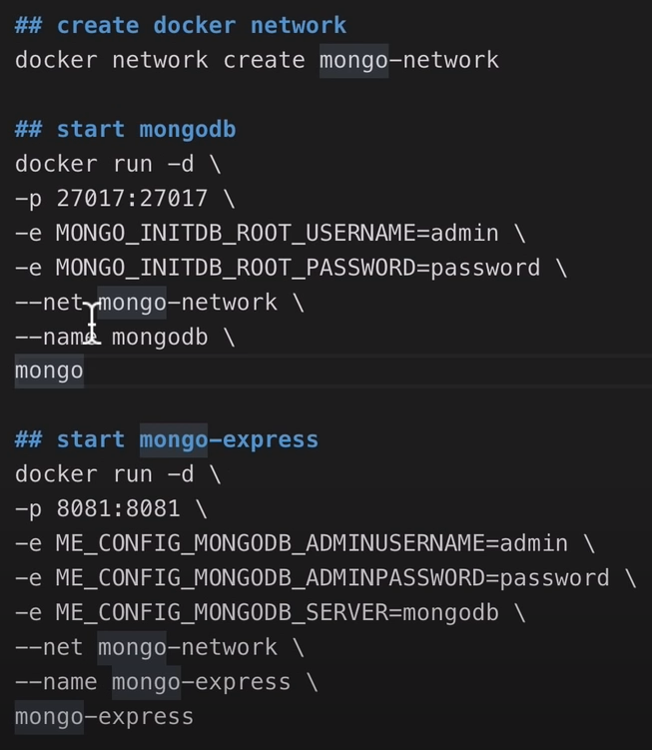

OR

Use Docker compose

create a .yaml file

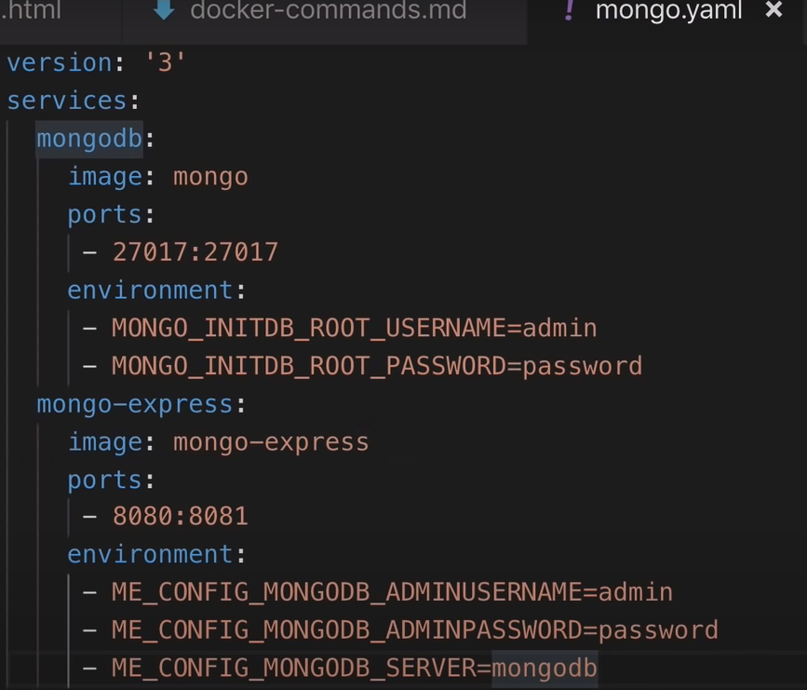

docker-compose defines a network by default

docker-compose -f <.yaml file name> up

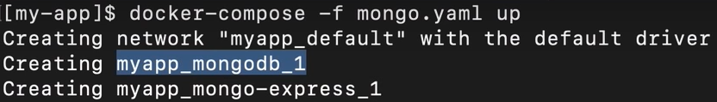



docker-compose -f <.yaml file name> down

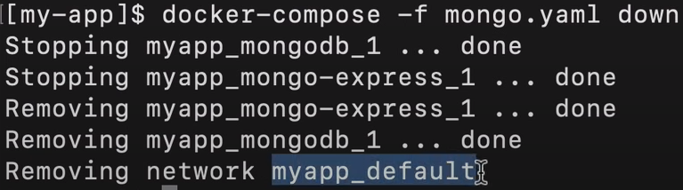

Stops and removes the containers and networks

Now dockerize(containerize) the node.js app

Create a file called Dockerfile

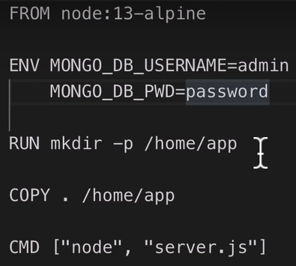

FROM

* Base the image from an existing image

ENV

* Set environment variables for the image

RUN

* Execute any linux commands inside the container image
* Can have multiple RUN commands

COPY

* Copies files from host to container
* Source file must be within the working directory

CMD

* Acts as entry point
* Can have only one CMD command

Now build the image

docker build -t <image name>:<version name> <Dockerfile location>



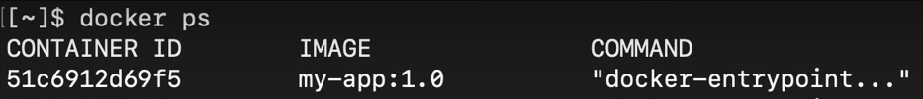

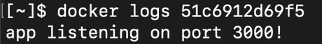

Can execute linux commands inside the container



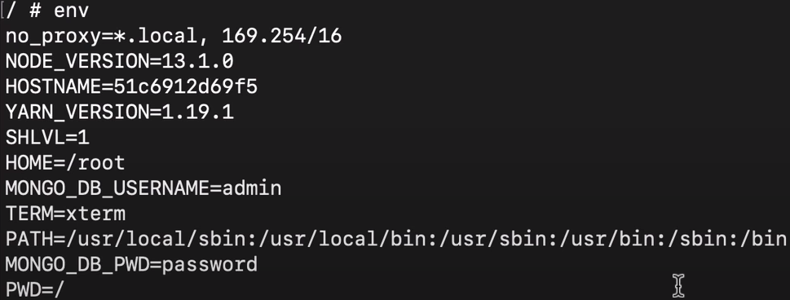



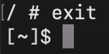

Need to rebuild image when something is changed

Docker volumes

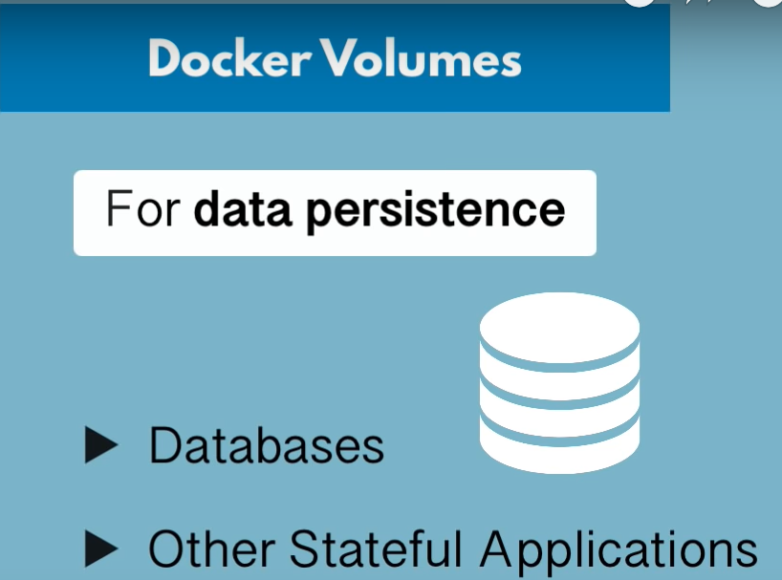

Data is lost when container is restarted, therefore we use volumes to persist data

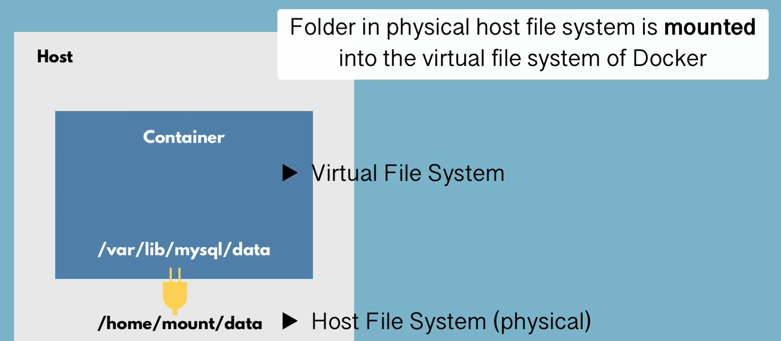

If data is changed in host file system, it gets reflected in container file system

3 types of volumes

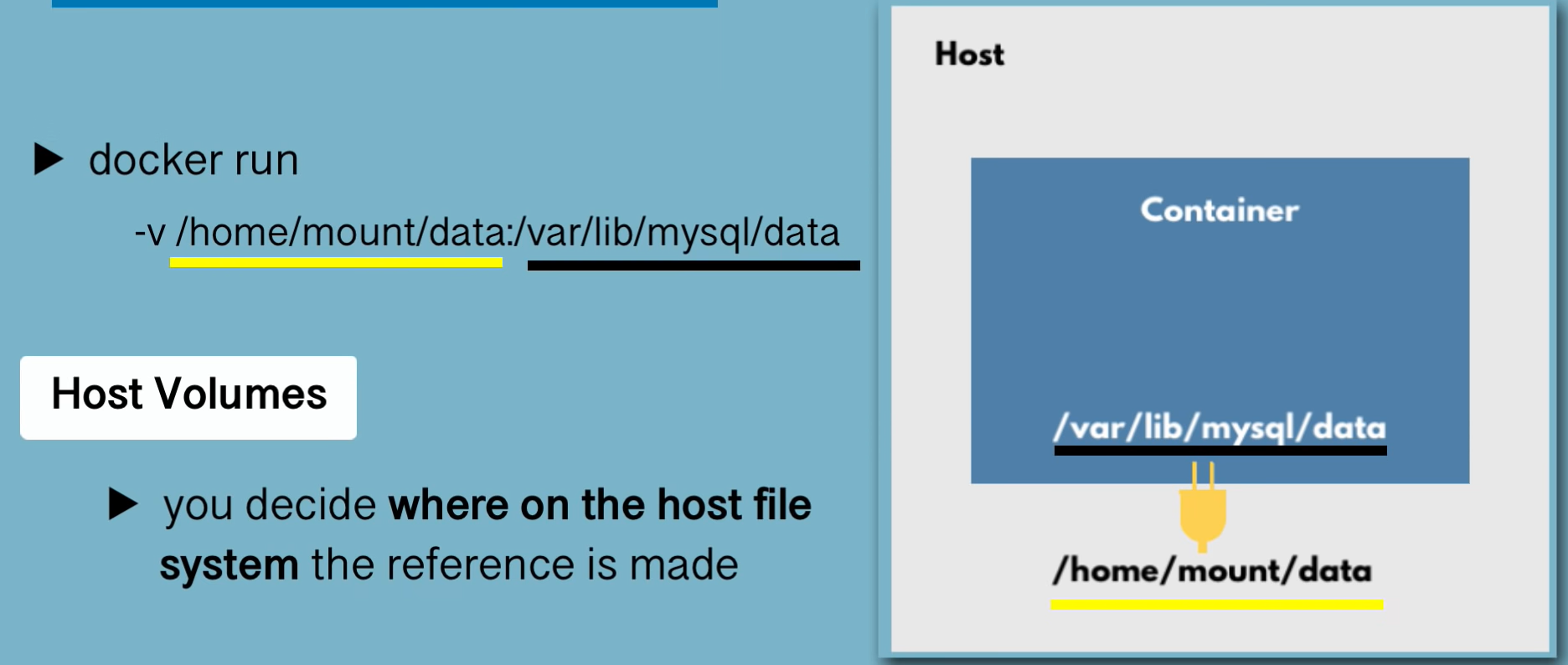

We tell where to store the data on host

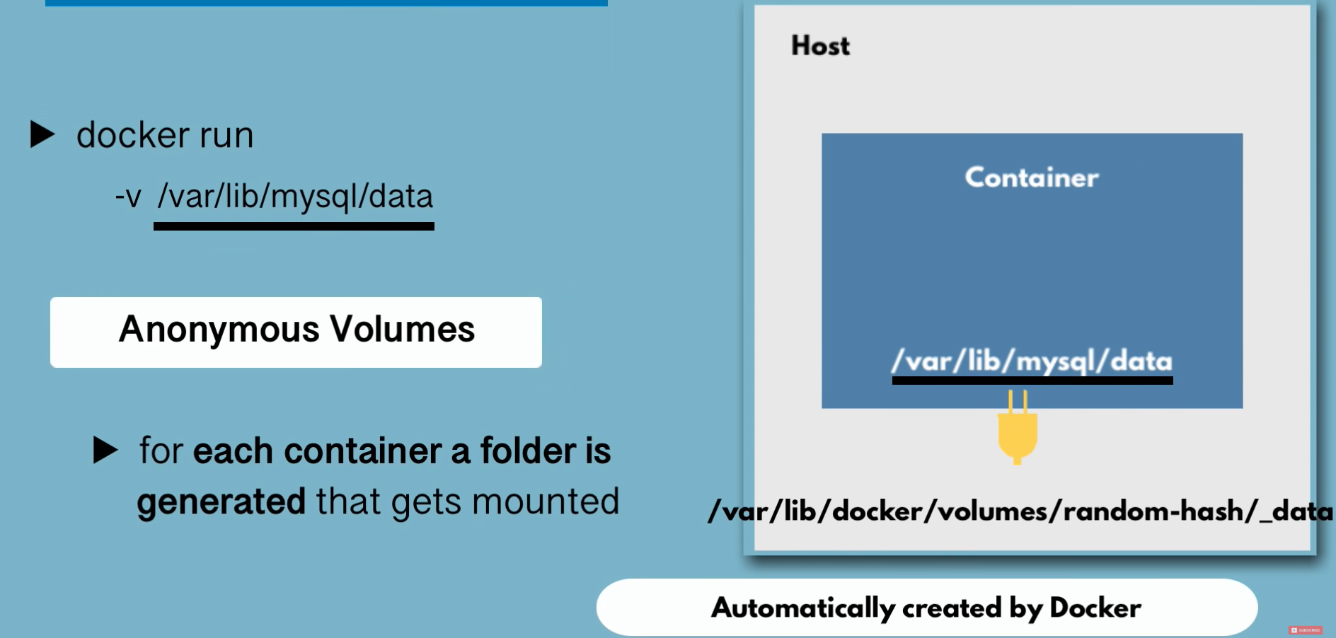

Docker takes care of folder creation for container data on the host

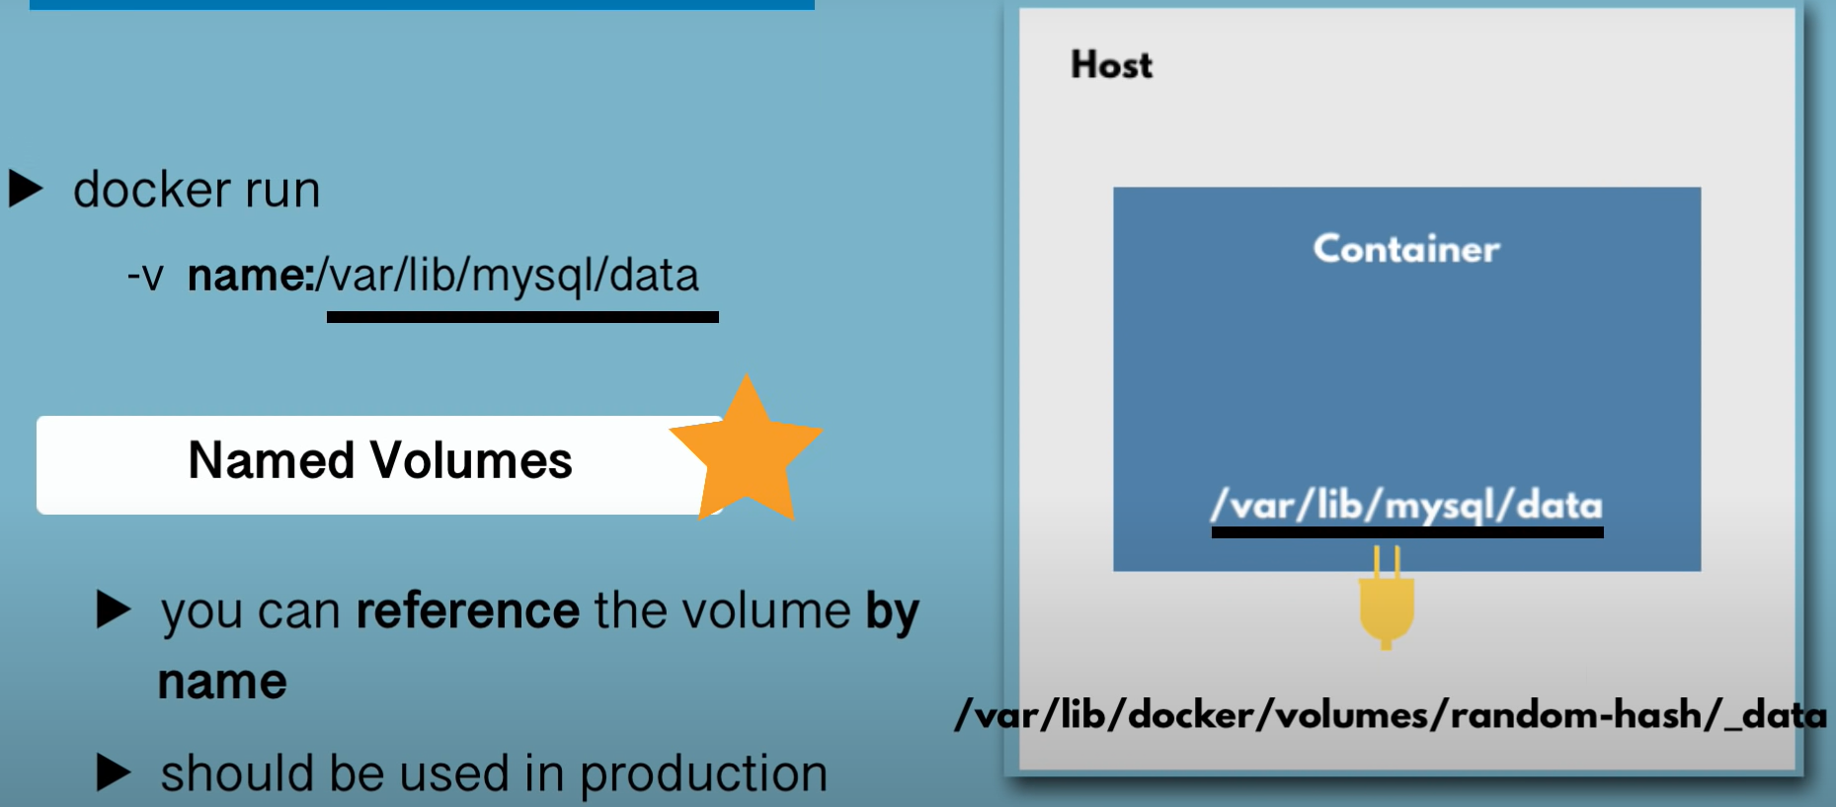

We reference the container data by name

This is the most preferred and advantageous since docker optimizes saving of the data

Using volumes in server deployment

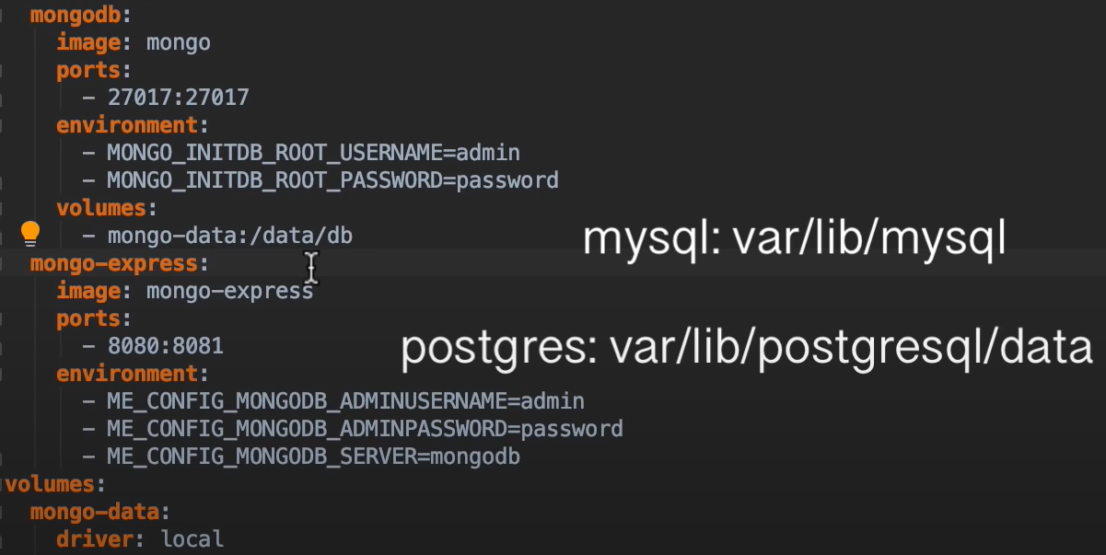

Volume name is mongo-data

Can use the named volume mongo-data in other containers too

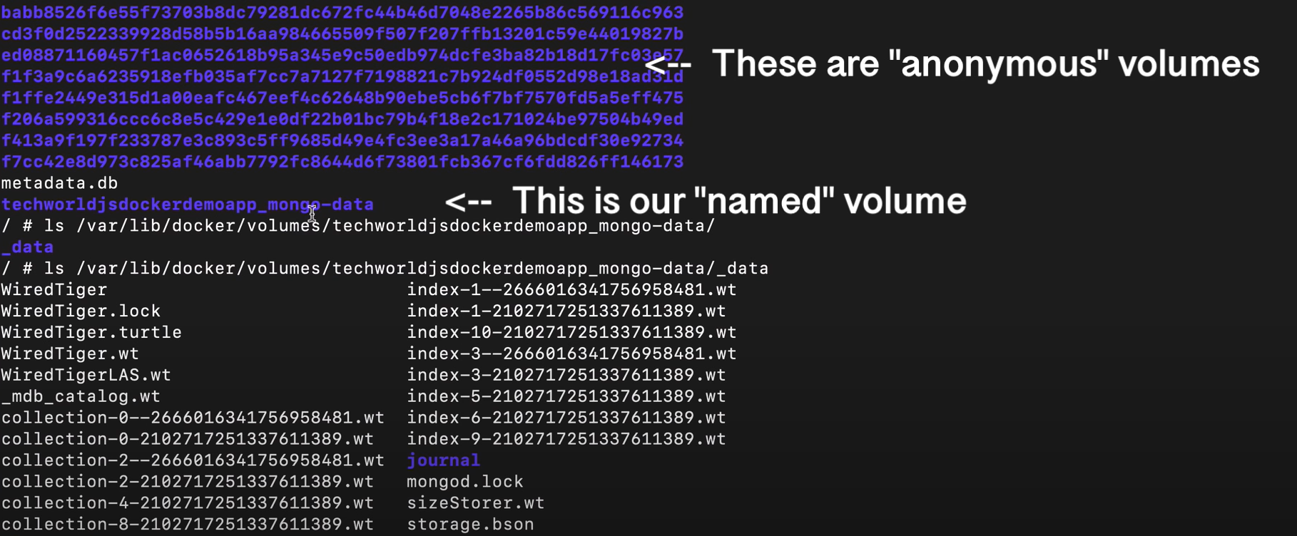

Push app image to private repository

In AWS

Go to ECR

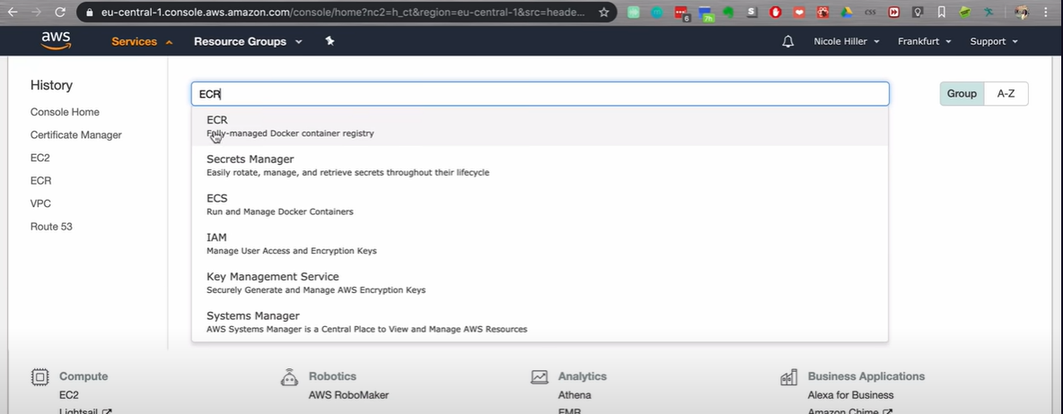

Click on create repo

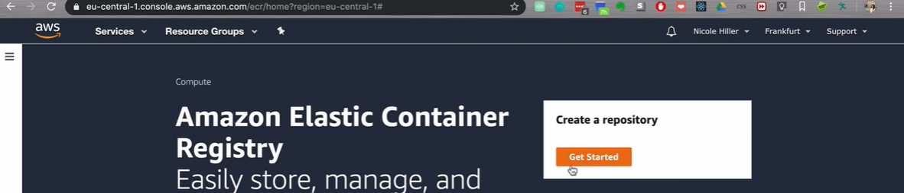

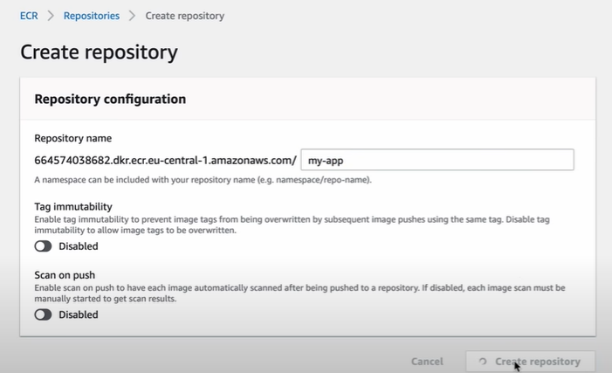

In AWS, we can have only 1 image / repo, but can have multiple versions of the same image / repo

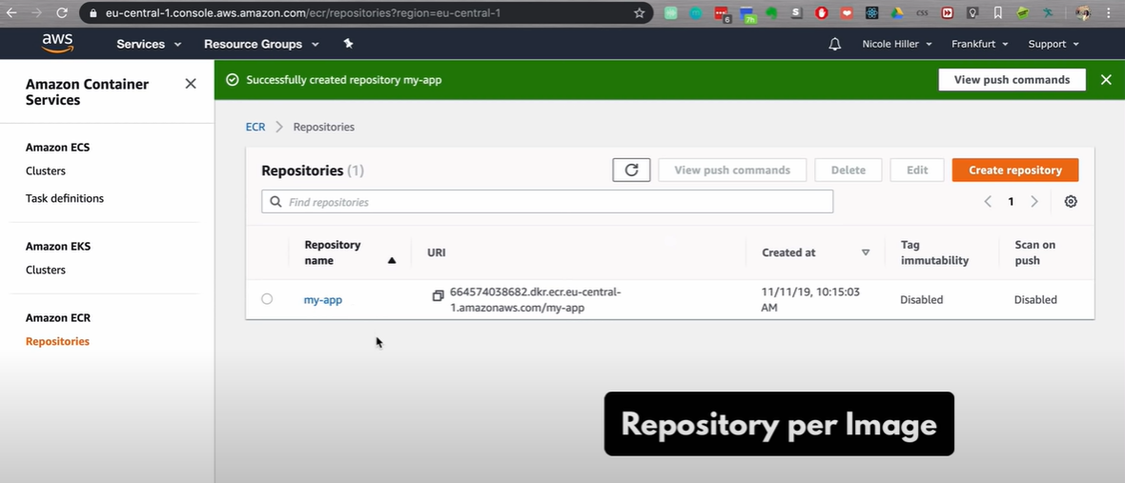

1. Login

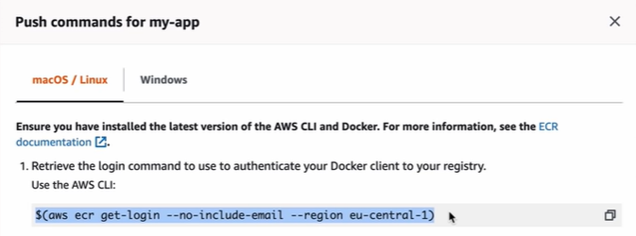

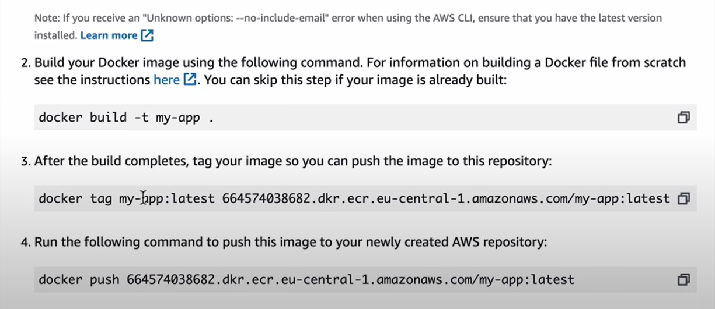



Pre-requisites

* + Need to have AWS command line interface
  + Credentials configured

By default in docker hub, it is preconfigured to attach registryDomain before imageName

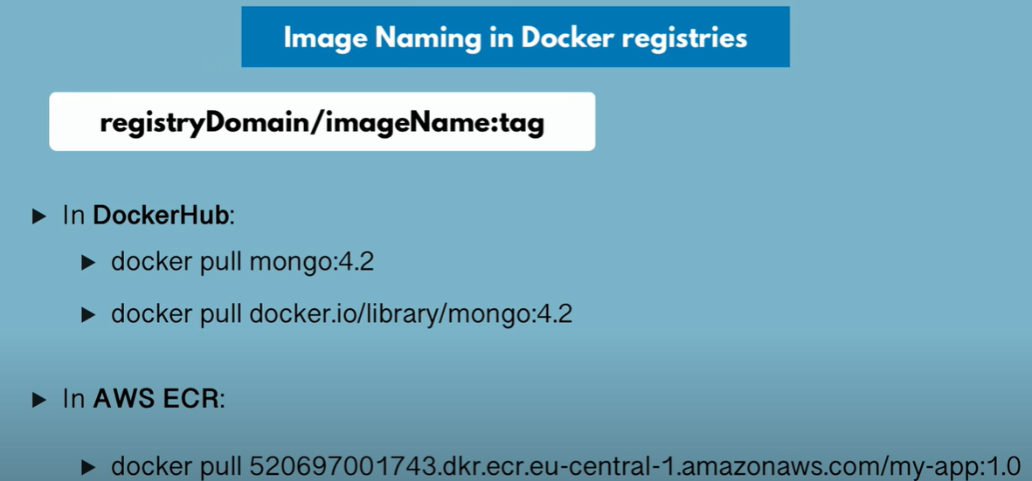

Let’s deploy the app in server

1)Login in server

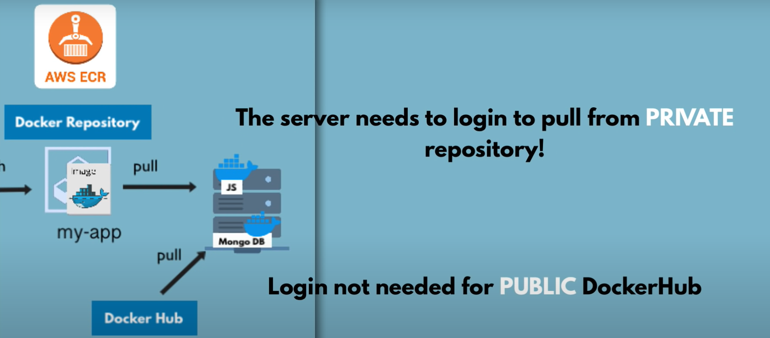

1. Copy .yaml in server

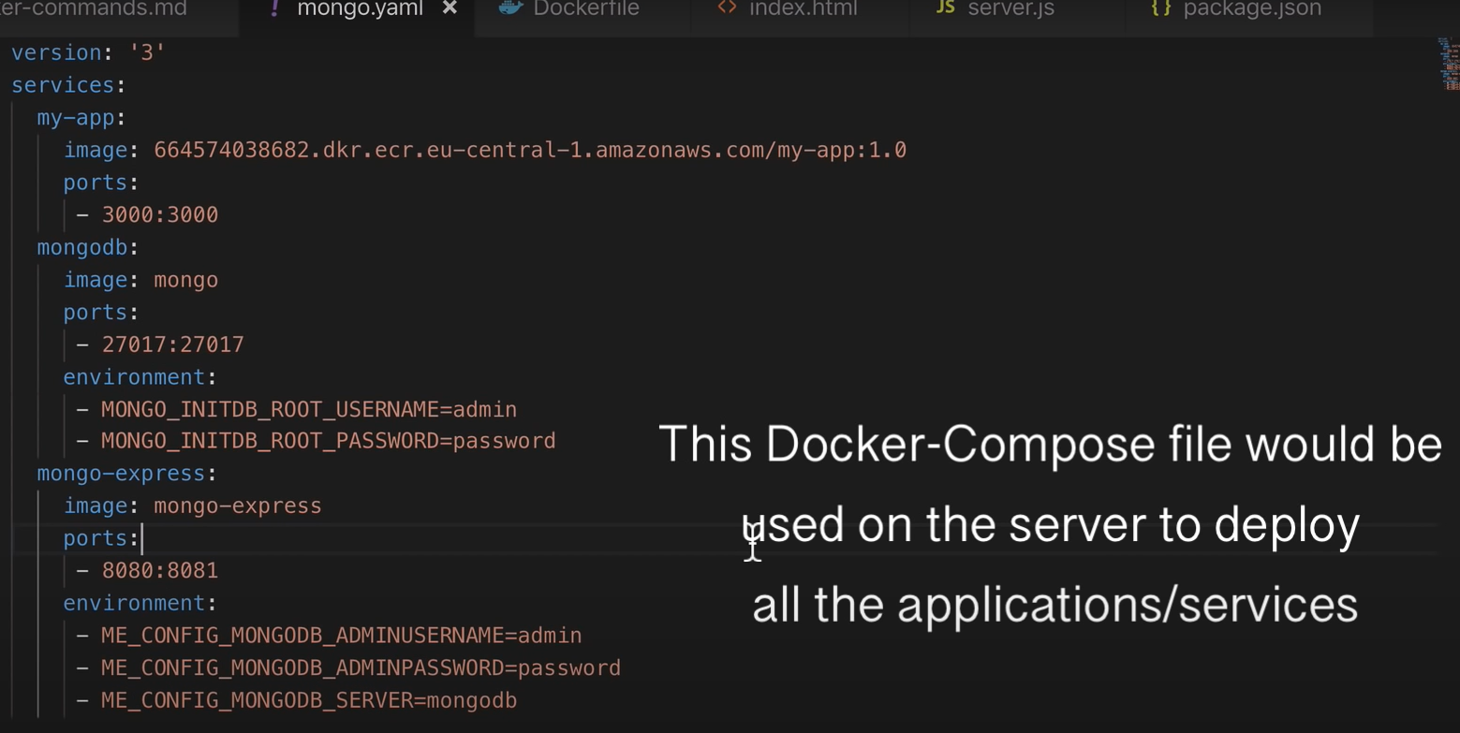

3) Use docker-compose to run all containers



In code, we can use .yaml file references for connecting to different services







We do not even need to specify port no.

GENERAL RULES:

1. Always use specific base image tag in Dockerfile, since the latest tag keeps changing.

eclipse-temurin:17-jdk-jammy is preferred over eclipse-temurin:latest

1. Keep image size small
   * Start with appropriate base image
   * Use multistage builds - For instance, you can use the maven image to build your Java application, then reset to the tomcat image and copy the Java artifacts into the correct location to deploy your app, all in the same Dockerfile. This means that your final image doesn't include all of the libraries and dependencies pulled in by the build, but only the artifacts and the environment needed to run them.
   * Reduce the no. of run commands

* [RUN](https://docs.docker.com/reference/dockerfile/#run) apt-get -y update
* [RUN](https://docs.docker.com/reference/dockerfile/#run) apt-get install -y python

Instead of the above

[RUN](https://docs.docker.com/reference/dockerfile/#run) apt-get -y update && apt-get install -y python

* + Use volumes to store data instead of container space, as container space is less efficient in an I/O perspective

Inside a container, all application references are subjective to container level, not host level

ex :

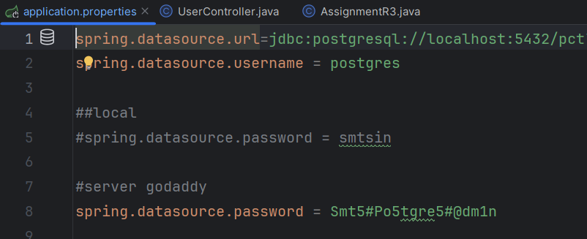

localhost in the above image will refer to container’s localhost, therefore DB connection will fail, to avoid this we need to use **host.docker.internal** instead of localhost

